1. Lets see the question “ Write a query for subcollection “RegisteredEvent” where “pid” is equal to “V4PrZSUiMpxEv1L24sKH” in pycharm”

* First you understand for this question, what is mean by sub-collection
* Below is the link for reference please go through it and practice in pycharm

<https://firebase.google.com/docs/firestore/query-data/queries#collection-group-query>

1. In the above link he given perfect explaination about how to write a query for subcollection
2. Lets see out firebase design , please go through the below screenshot

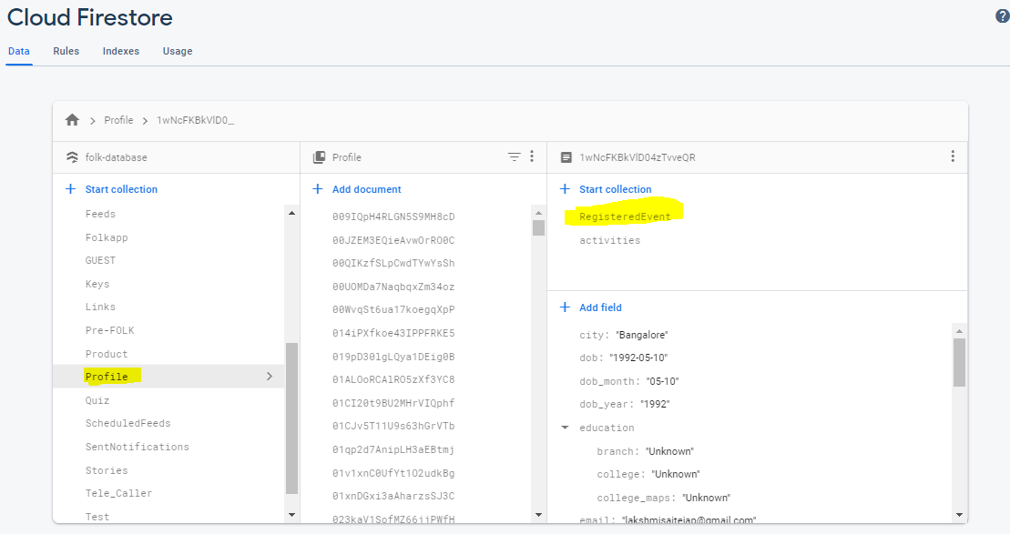

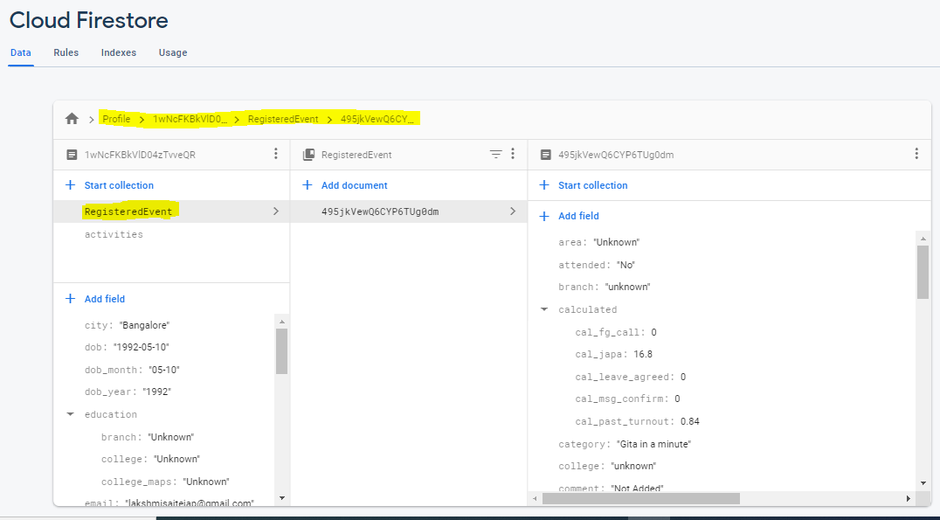

In the above screen shot the path for registered event is “/Profile/1wNcFKBkVlD04zTvveQR/RegisteredEvent/495jkVewQ6CYP6TUg0dm”

Profile-> collection

1wNcFKBkVlD04zTvveQR->profile document id

RegisteredEvent-> subcollection

495jkVewQ6CYP6TUg0dm -> RegisteredEvent document id

1. Lets see the solution
2. Docs = db.collection_group(u’ RegisteredEvent’).where(‘pid’,u’==’,’ V4PrZSUiMpxEv1L24sKH’).stream()

For doc in docs:

Print(doc.to_dict())

* Collection_group , we write on above to retrieve the data from sub-collection
* Remaining part as it is only collection we change has collection_group